In this paper, I have used R Studio and data visualizations to illustrate the impact of terrorism on the Happiness Index.

First, I installed all the necessary packages and then loaded the libraries.

The data set used for this report is Global terrorism and 2015 Happiness data set.

1. Installing packages and loading libraries

1. Next, is data visualization for Happiness score and the number of terror attacks on civilians in the year 2015 using ggplot.

According to the globe map shown above, the happiness index ranges from 3 to 7, with 3 being the lowest score with a darker shade of blue and 7 representing the highest score  with a lighter shade of blue.

1. Correlation of all the factors influencing both happiness and terrorist attacks

The high negative correlation between happiness score, family, and freedom and terrorist acts is clearly seen in the graph above.

1. Data visualization for happiness rank vs terror attack

1. Data visualization of Sense of Freedom and terror attacks

According to the graph above, there is less sense of freedom when there are more terror attacks, and greater sense of freedom when there are less terror attacks.

1. Data visualization for dystopia and terrorism. ( Dystopia is an imaginary nation with the unhappiest citizens in the entire planet. Dystopia was created with the intention of serving as a standard against which all other nations may be favorably compared (no nation does worse than Dystopia in terms of each of the six essential factors), enabling each sub-bar to have a positive width.)

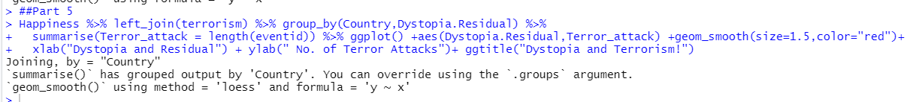

1. Plotting a bar graph using ggplot for visualizing Happiness Rank with respect to the number of terror attacks.

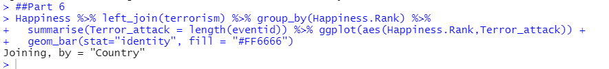

***Conclusion***

Terrorism's effects on society have always been detrimental to citizens. Obviously, this will have an impact on the global happiness index. Using the rworldmap package, we can use this report to see how terrorism affects the global happiness index. Additionally, I created a correlation graph between the happiness index and terrorist attacks. The other graphs provide us a quick overview of how terrorism affects many factors, including as a sense of freedom and dystopia.